Exercise

# Problem 12.1 from erickson (page

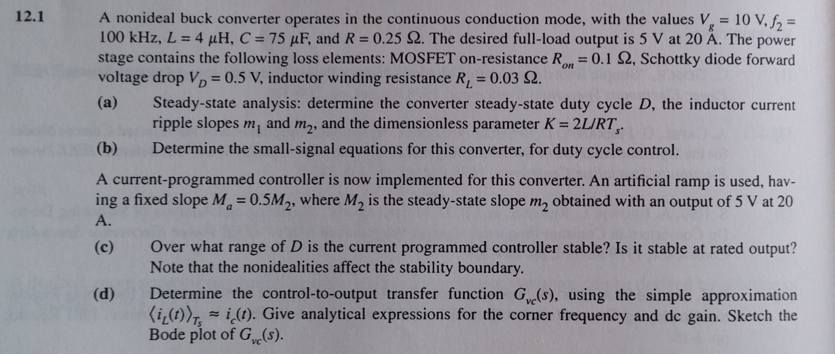

Corner frequency, DC gain and Bode are optional (d)



Figure : Buck converter with current programmed control